Michael kahr

LA-Parking-data

Handbook

**Project Application**

**Los Angeles Parking Citations**

**Author / Developer**Michael Kahr

**Vision**

* **Benefit for the users:** The user can just select a new csv file and see where the most citations happened, when and which type they were.
* 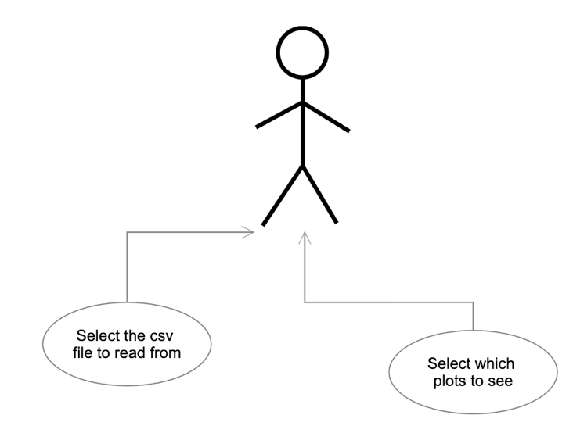**Business value:** The city of Los Angeles can use this map to see where they need to put more security or improve the signage

**Project Objectives**

* **Use Case Diagram:**
* **Product Backlog:**
  + As a user, I am  
    able to select a csv

File that should be used.

* + As a user, I can decide which plots

I want to see.

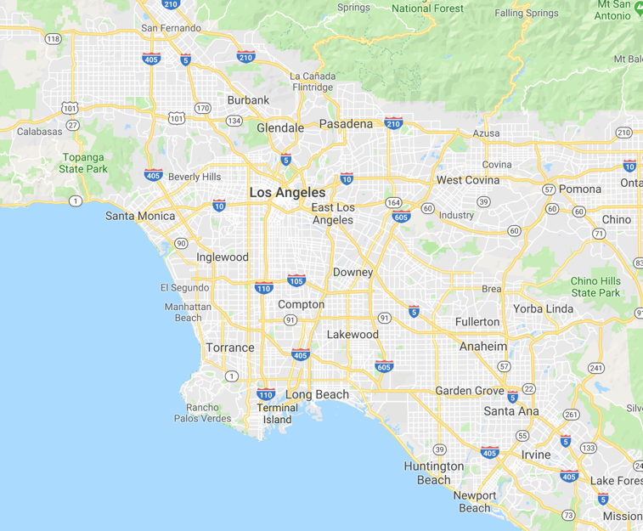**Technical Areas**The programming language will be python 3. The library for reading the csv file in and creating a dataframe is pandas. For calculation in the rows numpy will be used. Plotly or matplotlib will be used for the plots. Folium or gmaps will be used for the map.

**Mock-up**

**Milestones**

1. Read the csv file in and clean it
2. Collect important information
3. Display basic plots about the citations
4. Show a map where the most cases happened.

Story: Explore the Map

The user sees a google maps image of los angeles with 50  
location where the most citations happened.

He can explore the map and zoom in and out

Projekt: LA-Parking Data

Task: Create plot MA:____

Story: S M L



Wireframe:



Task: Get coordinates MA:_____

Tasks of Map:

1. Get coordinates of street
2. Create plot

Tests:

1. Coordinates will get pulled from api and saved
2. Google maps plot will be shown without errors

Negativ:

1. No points are shown on the map

Tests:

1. Create arrays for coordinates
2. Connect to api
3. Get coordinates for every street and save it in the array



Tests:

1. If everything is correct, the google maps image will be shown.

Negativ:

1. exception will get thrown if some data is corrupt

Story: Show plots

The user can choose which plots to see and get statistics  
about the data. E.g. what citations happened the most   
and how many citations happened every day. Some plots  
are interactive and the user can zoom in and so on

Projekt: LA-Parking Data

Task: display plot MA:____

Story: S M L



Wireframe:



Task: clear data MA:_____

Tasks of plots:

1. Clear the data
2. display plot

Tests:

1. only correct data will be used
2. plots only show things they should be

Negativ:

1. plots show incorrect data or don’t work

Tests:

1. Filter null values
2. Sort the data
3. Normalize it



Tests:

1. The plot is shown with the correct data.

Negativ:

1. exception will get thrown or false/corrupt data is displayed

**Program description:**

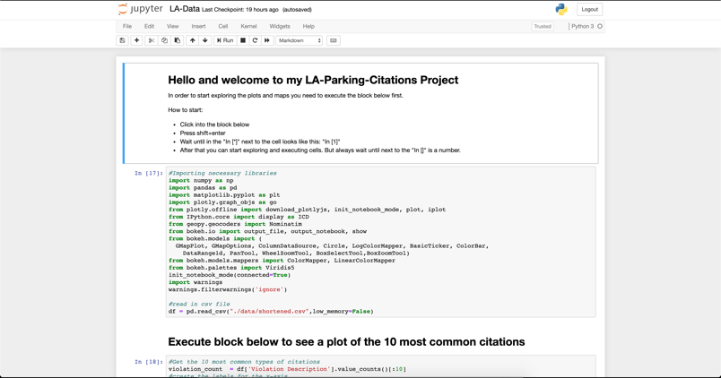You start the program by typing “jupyter notebook LA-Data.ipynb”. A browser will open and you will see the notebook. Before you start the program for the first time you need to install python 3 and pip3. Then type “pip3 install -r requirements.txt”. You need to be in the folder of the project to do this. When the notebook opened you should see something like this:

On the top of the page is a tutorial on how to use it and get plots. The plot with the daily citations is interactive. When you hover over it with the mouse, you see the amount for every day. On the top side are tools for zooming in and out and other things.

**Sprints:**

**Sprint 1 (to 10.05.2019)**

In the first sprint, the tasks were:

* Find the right dataset
* Clear the data
* Create the plots

Resources used:

Dataset: <https://www.kaggle.com/cityofLA/los-angeles-parking-citations>

Plotly tutorial: <https://plot.ly/python/ipython-notebook-tutorial/>

**Sprint 2 (to 16.06.2019)**

In the second sprint, the tasks were:

* Reseach about the google maps api
* Get coordinates of location
* Plot points on map

Resources used:

Maps: <https://blog.goodaudience.com/google-maps-in-python-part-2-393f96196eaf>

Plotly tutorial: <https://plot.ly/python/ipython-notebook-tutorial/>

**Other Content in the directory:**

* ./data
  + The csv file is in there
* ./Documents
  + Project application,handbook
* LA-Dta.ipynb
  + The notebook with all the code
* Readme.md
  + Readme file from github
* Requirements.txt
  + The required python packages
* Gitlog.log
  + Log of the git commits

**Lines of code:**

120 Lines of code